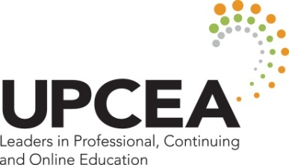

UPCEA REGION WEST
In Honor of Excellence
2014 Awards Application

CATEGORY: PROFESSIONAL CONTRIBUTIONS TO CONTINUING EDUCATION

Please complete this form and email it to the chair listed below. Please note: if your nominee wins, your institution is responsible for any travel costs to the fall regional conference (Oct. 1-3, Las Vegas, NV) should he/she like to accept the award in person. The Region West winner of this award will be automatically forwarded as a nominee for the UPCEA national Walton S. Bittner Service Citation for Outstanding Service.

Submission must be received by August 8, 2014

Criteria and Eligibility
- The nominee must be a member of a UPCEA institution.
- He/she must have contributed substantially to the development and maintenance of his/her institution and UPCEA through services performed over a period of years.
- Nominations by deans and directors on behalf of members of their staff are welcome and encouraged. Nominations from subordinates on behalf of superiors from their own institutions are excluded.

Complete the questions below:
1. Name and position of person:

2. Institutional affiliation:

Note: No timeline is required, but number of years working in CE may be taken under consideration.

3. Outstanding qualities that determine candidate’s qualifications:

4. Contributions to the field:

5. Other outstanding achievements, e.g. research and/or publications:

Please provide the following supporting documentation:
- A nomination form and at least two letters of nomination or support from informed individuals: e.g., an academic department chair or faculty member; dean or director of continuing education, president or vice president of the nominee’s institution. The letters must address the nominee’s accomplishments.
- Documentation of the candidate’s excellence in achievements must include material such as length of service, university involvement, community contributions, employment, job performance, and so forth.
- A current vita of the nominee.
- The nominee must be a UPCEA member.

6. Nominee’s bio. Please provide us with a short paragraph below (approx. 200 words) describing the person you are nominating. This will appear on the UPCEA West Region conference website.

Please email this completed document and any supporting material to melissa.nakamura@hawaii.edu.

Melissa Nakamura, Awards Committee Chair
University of Hawaii at Manoa
2440 Campus Road, Box 447
Honolulu HI 96822
Phone: (808) 956-6781
e-mail: melissa.nakamura@hawaii.edu

